**Assignment No.**

**Title:** A Mobile App for Calculator having Trigonometry functionality.

**Aim:** Implement Mobile App for Calculator having Trigonometry functionality is to be designed and tested.

**Objective:** To study and implement Trigonometry functionality in android studio.

To study and perform Positive and Negative testing.

To implement software design and testing in android platform.

**Theory:**

**Android Studio Overview**

Android Studio is the official IDE for Android application development, based on IntelliJ IDEA. On top of the capabilities you expect from IntelliJ, Android Studio offers:

Flexible Gradle-based build system

* Build variants and multiple apk file generation
* Code templates to help you build common app features
* Rich layout editor with support for drag and drop theme editing
* lint tools to catch performance, usability, version compatibility, and other problems
* ProGuard and app-signing capabilities
* Built-in support for [Google Cloud Platform](http://developers.google.com/cloud/devtools/android_studio_templates/), making it easy to integrate Google Cloud Messaging and App Engine
* And much more

## Set up the environment

Before you can build an app, you need to set up your development environment:

1. Download and install [Android Studio](http://developer.android.com/sdk/installing/studio.html).
2. Launch Android Studio.
3. From the Quick Start menu on the welcome screen, select **Configure > SDK Manager**.

If you already have a project open, you can open the SDK Manager by selecting **Tools > Android > SDK Manager** from the Android Studio menu bar.

1. In Android SDK Manager, select the following items and then click **Install packages**:
   * 1. Tools/Android SDK Tools
     2. Tools/Android SDK Platform-tools
     3. Tools/Android SDK Build-tools
     4. Android API (currently recommended: API 19)
     5. Extras/Google Repository
     6. Extras/Android Support Repository

## Create a new project

1. Launch Android Studio.
2. In the Welcome to Android Studio screen, choose **New Project**.
3. In the New Project window, enter the application name, module name, package name, and project location.
4. This example uses CouchbaseEvents for the application name.
5. Set the minimum required SDK to **API 9: Android 2.3 (Gingerbread)** or later and use the currently recommended Android API.
6. Click **Next**, and then move through the remaining setup screens and enter settings as necessary (or just accept the defaults).
7. Click **Finish**.
8. **Input:** Get two numbers and the operation desired.

**Software Modelling & designing**

**Algorithm**:

Step 1: Start Application

Step 2: Enter valid number in float or double or integer format.

Step 3: Press a button for a specific operation.

1.Add() 6.Cos()

2.Sub() 7.Tan()

3.Mul() 8.Cot()

4.Div() 9.Sec()

5.Sin() 10.Cosec()

Step 4: Get the result.

**System testing:**

For testing purpose we have used manual testing.

**Mathematical Modelling**:

Let ‘S’ be the system such that,

S = {I, O, Fn, Sc, Fc}

Where,

I -> {I1, I2, . . . , In} : set of inputs

O -> {O1, O2, . . . , On} : set of outputs

Fn -> {Fn1, Fn2, . . . ,Fnn} : set of functions

Sc -> {Sc1, Sc2, . . . ,Scn} : set of success cases

Fc -> {Fc1, Fc2, . . . ,Fcn} : set of failure cases

**I: Set of Inputs**

I1: Number as input (float/double)

I2: Function to performed.

**O: Set of Outputs**

O1: Result of Operation

O2: Message for respective trigonometric function.

Fn6: cosine of value

Fn7: tan

Fn8: cot

Fn9: sec

Fn10: cosec

**Fn: Set of Functions**

Fn1: Addition

Fn2: Subtraction

Fn3: Multiplication

Fn4: Division

Fn5: sine of value

**Sc: Success Cases**

Sc1: valid credentials entered.

Sc2: Proper implementation of functions

**Fc: Failure Cases**

Sc1: Invalid credentials entered.

Sc2: Improper implementation of functions

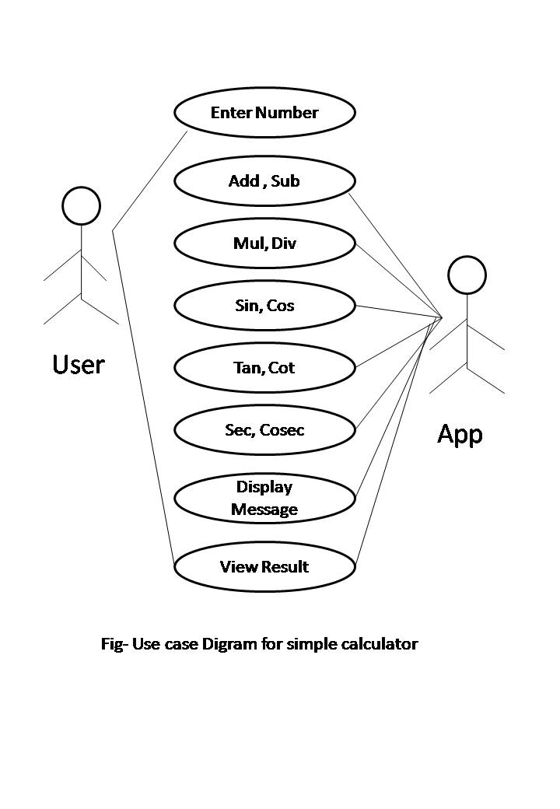

**Input** : Number in valid format

**Output**: Result of operation

**Platform :** Ubuntu 14.04 , ADT Bundle

**Language** : Java

**Conclusion** : Thus we have successfully complete Android Mobile App for Calculator having Trigonometry Functionality and tested on android mobile.